SIMATS ENGINEERING
ASSESSMENT TOOL 1 – Codings challenge

COURSE NAME: COMPUTER NETWORKS
COURSE CODE: CSA07

Challenge set 1: UDP Analysis
Sample to use: DNS+NTP
1. Open the DNS sample.
o Locate the UDP header.
o Write down the Source Port and Destination Port.
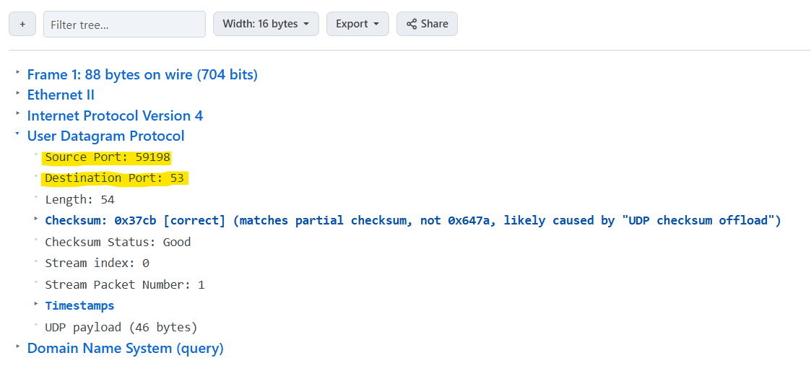
o What is the Destination Port number and which well-known service does it represent?

The Destination Port number specifies which service the packet is intended for. Each well-known port corresponds to a standard service:
- Port 80 → HTTP (Web traffic)
- Port 443 → HTTPS (Secure web traffic)
- Port 25 → SMTP (Email sending)
- Port 53 → DNS (Domain name resolution)
o What is the Destination Port number and which well-known service does it represent?

2. Still in the DNS sample:
o Find the UDP Length and Checksum fields.
o Does this packet have any sequence number or acknowledgement number? What does this tell
you about UDP?
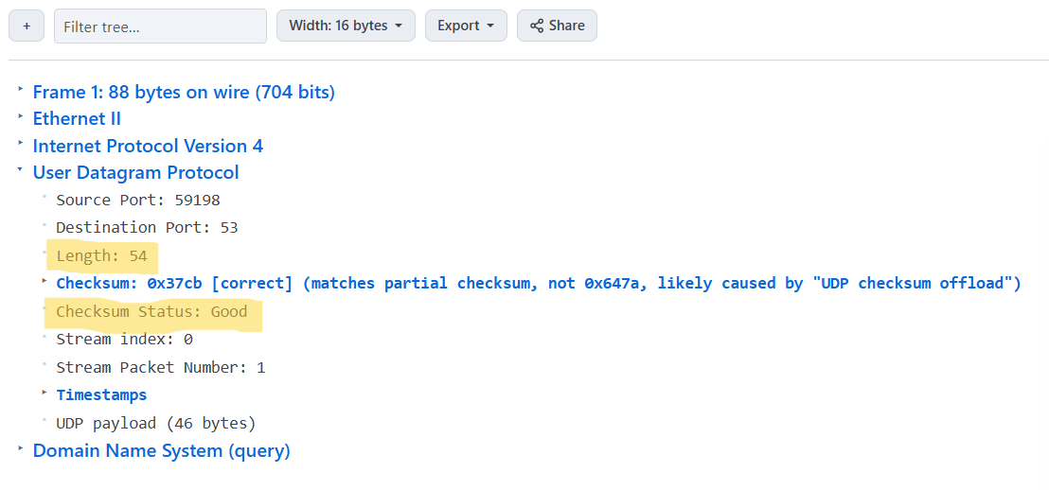
o Does this packet have any sequence number or acknowledgement number? What does this tell
you about UDP?

- This packet does not contain a sequence number or an acknowledgement number.
- Those fields exist only in TCP. Their absence confirms that UDP is a connection-less, best-effort transport: it provides no ordering, reliability, or flow-control mechanisms.

3. Open the NTP sample.
o Compare its UDP header with the DNS sample

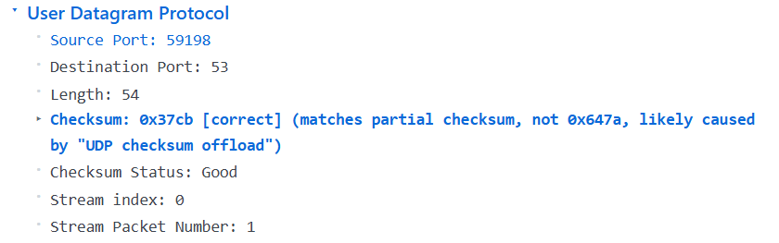
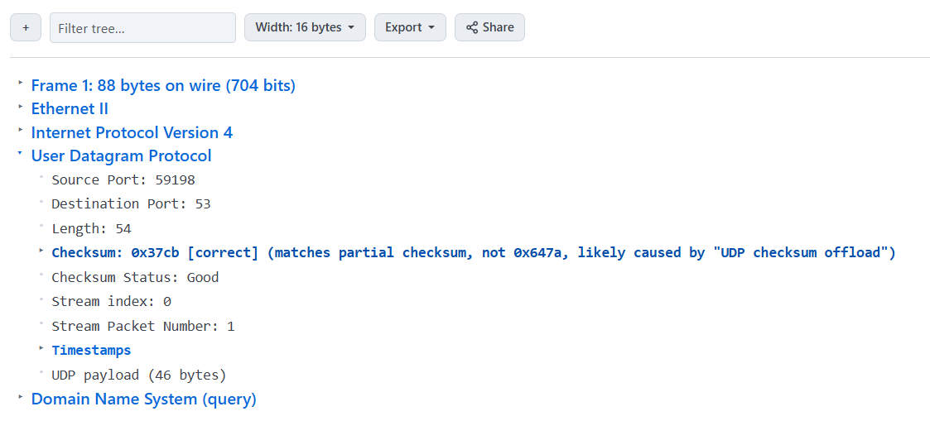

UDP field | NTP sample | DNS sample | Size
Source Port | Different value | Different value | 2 bytes
Destination Port | 123 (00 7B) | 53 (00 35) | 2 bytes
Length | NTP packet value | DNS packet value | 2 bytes
Checksum | NTP value | DNS value | 2 bytes
Total UDP header | 8 bytes | 8 bytes

o Are the header fields the same size?
Yes.
The UDP header used by both DNS and NTP has exactly the same structure and field sizes:
2 + 2 + 2 + 2 = 8 bytes
The values are different, but the field sizes are the same.

o Why is UDP suitable for both DNS and NTP?
DNS:
DNS usually needs a quick request-response exchange. UDP has a small 8-byte header and does not require connection establishment, so DNS queries can be sent quickly with low overhead.
NTP:
NTP exchanges small time-synchronization messages and needs low delay. UDP avoids the connection setup and extra overhead of TCP, making it suitable for frequent time synchronization.

Challenge set 2: TCP Analysis
Samples to use : FTP + My SQL
4. Open the FTP sample.
o Expand the TCP header.
o List the following fields with their values:
▪ Source Port
▪ Destination Port
▪ Sequence Number
▪ Acknowledgement Number
▪ Flags (which flags are set?)

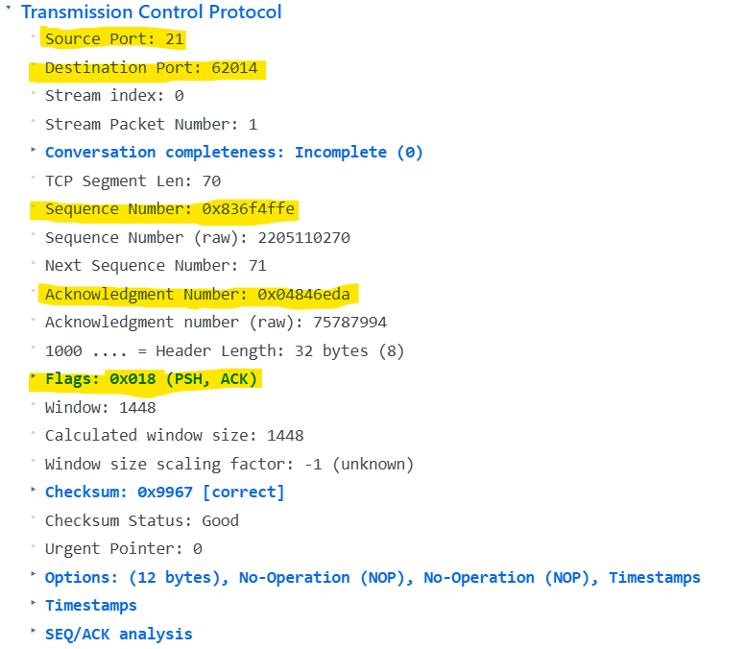

5. In the same FTP sample:
o What is the 4-tuple that uniquely identifies this TCP socket? 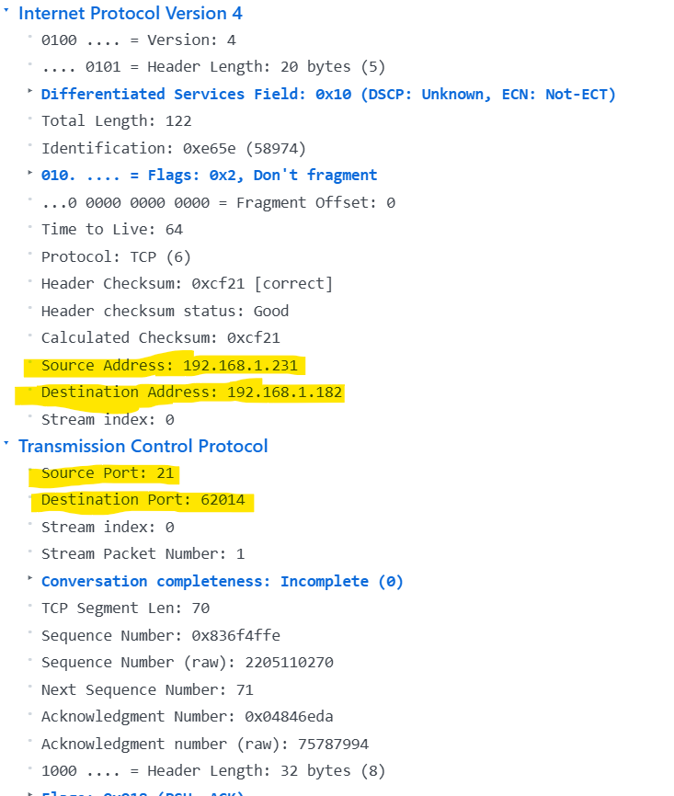

o Explain how this 4-tuple helps in demultiplexing.
4 – tuple
How it is used for demultiplexing
When a TCP segment arrives, the operating system examines the four fields above. Each active TCP socket is identified by its own 4-tuple, so the kernel can match the segment to the exact socket (process) that opened that connection. This allows many simultaneous TCP connections to coexist on the same host and IP address, because each connection is distinguished by the combination of source/destination addresses and ports. The matching socket then receives the segment for further processing (reassembly, ACK handling, etc.).
6. Open the MySQL sample.
o Compare its TCP ports with the FTP sample
➢ MySQL TCP Port: MySQL standard connections listen on TCP port 3306 (often targeted by client tools or script connections), while dynamic ports in the ephemeral range (e.g., 50000–65535) are allocated to the client side.
➢ FTP TCP Port: FTP control traffic listens on standard TCP port 21, while the client in your previous trace used port 62014.
o Are the Destination Ports the same or different?
- They are different.
- In a server-bound packet sent to MySQL, the destination port is 3306.
- In a server-bound packet sent to FTP, the destination port is 21.
- If the direction is from server to client, the destination port will match whichever dynamic high-numbered port the client allocated for that specific session
o How does the operating system know which application should receive each packet?
(Demultiplexing)
- Transport Layer Hand-off
- Socket Lookup Table
- 4-Tuple Matching
Challenge Set 3: TCP vs UDP Comparison
Samples to use: DNS (UDP) + FTP (TCP)
7. Place the DNS and FTP samples side-by-side (open one after another).
o Which protocol has a larger header?
- FTP (TCP) has the larger header. Because:
- FTP-32 bytes
- DNS-8 bytes

o Which protocol provides reliability features (sequence numbers, flags, window)?

- TCP (Transmission Control Protocol)

o Which protocol is connection-oriented and which is connectionless? Give evidence.
- FTP (TCP) is Connection-Oriented.
Evidence:
It utilizes stream indices, dynamic sequence numbers, and acknowledgment numbers to track the exact offset of data in an established end-to-end stream.
- DNS (UDP) is Connectionless.
Evidence:
The DNS client simply sends a standalone datagram directly to destination port without establishing a persistent socket session first.

8. From the FTP sample:
o Point out any fields that show TCP’s duty of providing reliability and flow control.
- Reliability: Sequence Number / Acknowledgment Number.
- Flow Control: Window Size.
Challenge Set 4: Modern Transport
Sample to use: QUIC
10. Open the QUIC sample.
o Which underlying Transport protocol is QUIC using? (Look carefully)
Underlying transport protocol: UDP (User Datagram Protocol) – the QUIC packet is encapsulated in a UDP datagram.
o What is the Destination Port?
Destination port: 443 (the standard HTTPS/TLS port).
o How is QUIC different from classic TCP even though it runs over UDP?
- Built on UDP: QUIC implements its own retransmission, flow-control, congestion-control, and reliability mechanisms in user space, so it does not rely on TCP’s built-in reliability.
- Integrated TLS 1.3: Encryption and authentication are part of the QUIC handshake; the connection is always encrypted, unlike TCP which can be plaintext.
- 0-RTT / 1-RTT connection establishment: After the first successful connection, subsequent connections can resume with zero round-trips, reducing latency compared to TCP’s three-way handshake.
- Multiplexed streams: Multiple independent streams share a single QUIC connection without head-of-line blocking; loss on one stream does not stall others, whereas TCP suffers head-of-line blocking across the whole connection.
- Connection migration: Because QUIC runs over UDP, a client can change IP addresses (e.g., move from Wi-Fi to cellular) without breaking the connection, something TCP cannot do without tearing down the session.

